Name

Mathematics Extension 1 Year 11
Further Inequalities

Book 1 |  | Version: 261020  Feedback:  https://MrDingMaths.com
Contents
Syllabus Content 2
Learning Intention 3

Syllabus Content
ME1-11-01 solves problems involving inequalities, functions and their inverses, graphical relationships between functions, and parametric equations
Inequalities
- Solve cubic inequalities where the cubic is expressed as a product of linear factors
- Solve inequalities involving rational expressions with variables in the denominator
- Solve absolute value inequalities of the form $|ax+b|≥k$, $\left|ax+b\right|≤k$, $\left|ax+b\right|<k$, $\left|ax+b\right|>k$, where $a$, $b$ and $k$ are constants, using algebraic and graphical methods or the characterisation of $\left|x\right|$ as the distance of $x$ from the origin

Cubic Inequalities

- Identify domain where $y>0$ or $y<0$
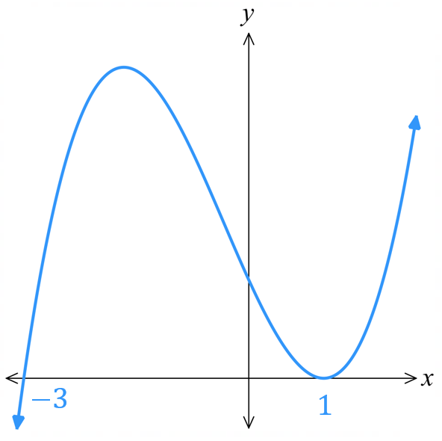  $y>0:$  $-3<x<1$  $y<0:$  $$x<-3, x>1$$ | 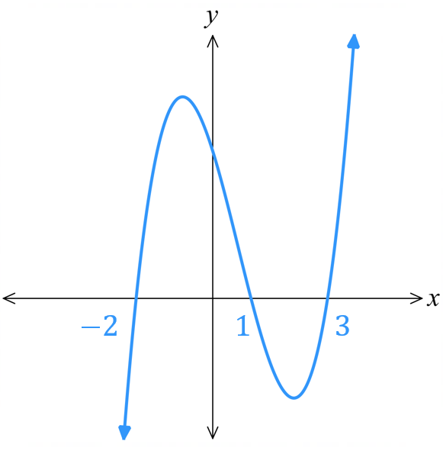  $y>0:$  $$-2<x<1, x>3$$  $y<0:$  $$x<-2, 1<x<3$$ | 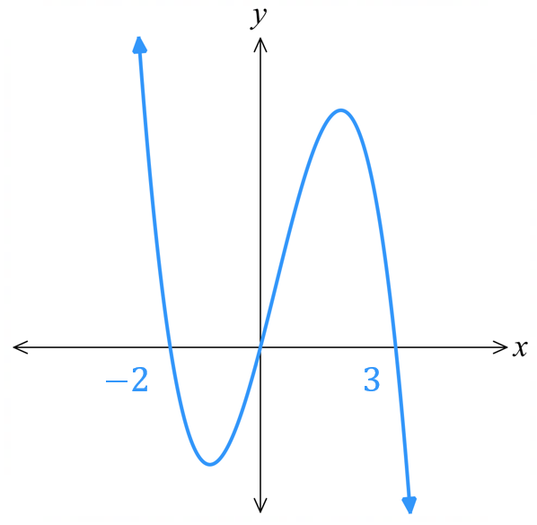  $y>0:$  $$x<-2, 0<x<3$$  $y<0:$  $$-2<x<0, x>3$$
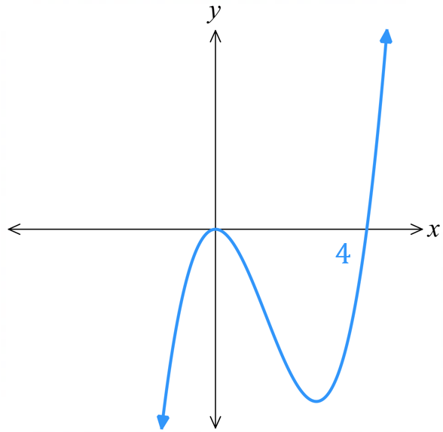  $y>0:$  $$x>4$$  $y<0:$  $$x<0, 0<x<4$$ | 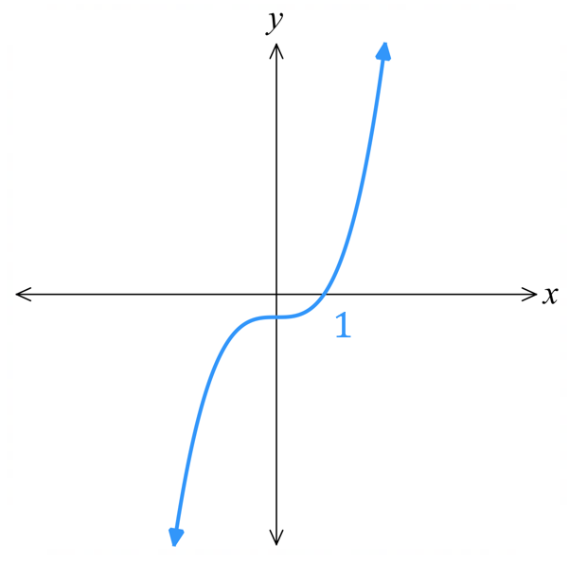  $y>0:$  $$x>1$$  $y<0:$  $$x<1$$ | 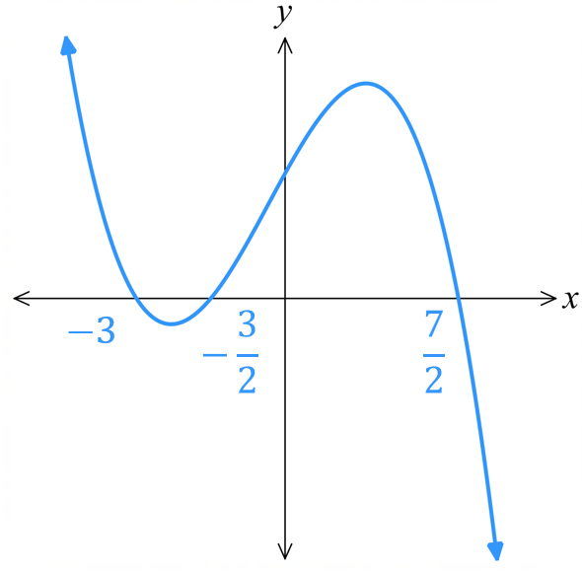  $y>0:$  $$x<-3, -\frac{3}{2}<x<\frac{7}{2}$$  $y<0:$  $$-3<x<-\frac{3}{2}, x>\frac{7}{2}$$

- Cubic Inequalities
We solve cubic inequalities the same way as we solve quadratic inequalities:
- Sketch the cubic curve $f(x)$, showing all $x$-intercepts.
- Examine where the graph is above or below the $x$ axis.

- Example Solve cubic inequalities given in factored form
Solve $\left(x+2\right)\left(x-1\right)\left(x-3\right)≥0$  1.  Leading term is $x^{3}$,  $x→∞$, $y→∞$  $x$-int:  $x=2, -1, -3$  2.  $-2<x<1, x>3$ | 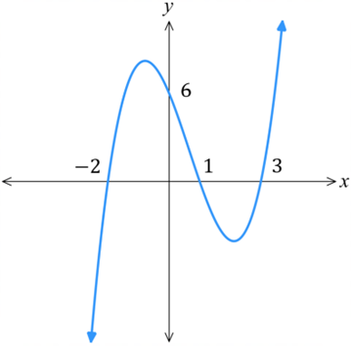  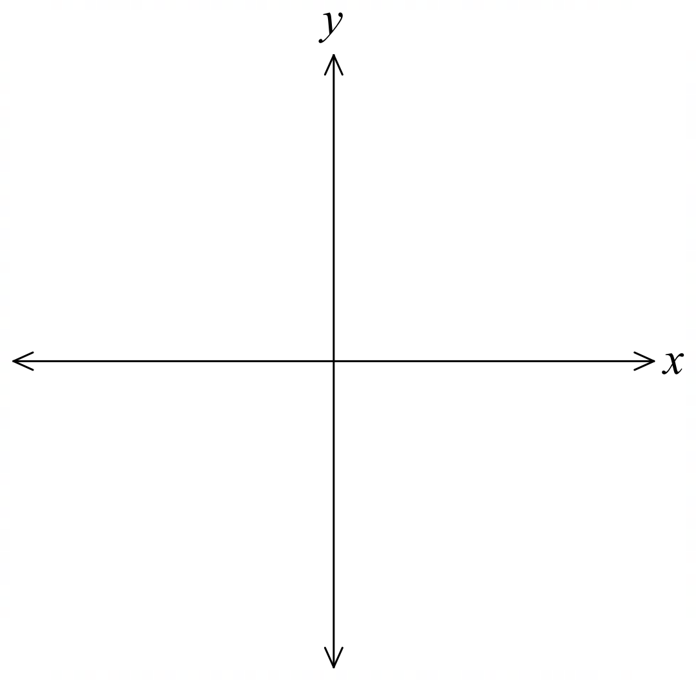

- Guided Practice
Solve:
- $\left(x-1\right)\left(x+2\right)\left(x-3\right)≤0$  $$1≤x≤3, x≤-2$$ | - $-x\left(x+2\right)\left(x-3\right)>0$  $$0<x<3, x<-2$$

Foundation
- Solve these cubic inequalities by referring to the given graph.
- $x\left(x-1\right)\left(x-3\right)≥0$  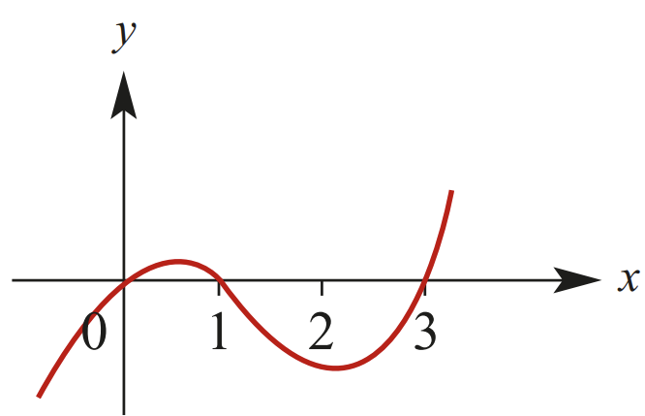  $$0≤x≤1, x≥3$$ | - $\left(2x - 1\right)\left(x - 2\right)\left(x + 3\right)<0$  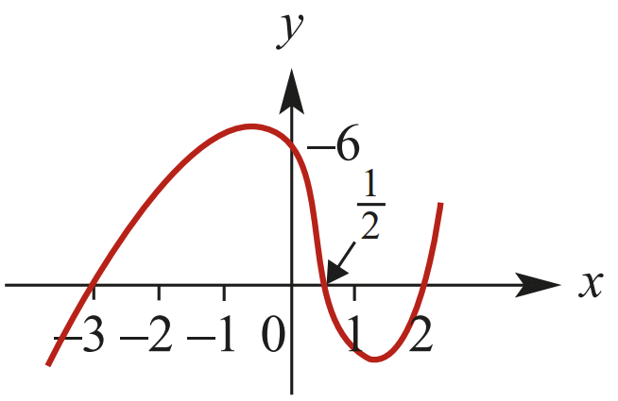  $$x<-3, 0.5<x<2$$ | - $\left(x-1\right)\left(3-x^{2}\right)≥0$  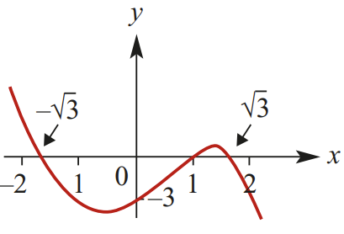  $$x≤-\sqrt{3}, 1≤x≤\sqrt{3}$$
- $\left(x-1\right){\left(x-2\right)}^{2}≥0$  $$x≥1$$ | - $x^{2}\left(x-4\right)<0$  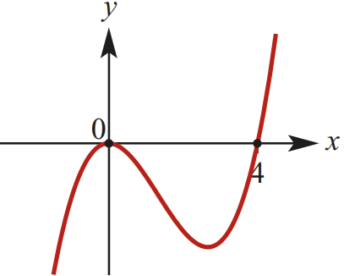  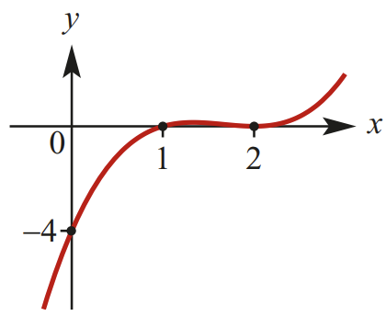  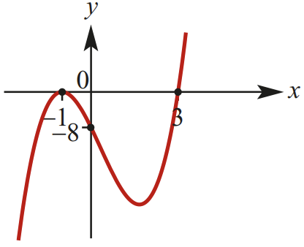  $$x≤4, x≠0$$ | - $2{\left(x+1\right)}^{2}\left(x-3\right)<0$  $$x<3, x≠-1$$

- Solve these cubic inequalities.
- $\left(x-1\right)\left(x+1\right)\left(x-4\right)≤0$  $$1≤x≤4, x≤-1$$ | - $\left(x+2\right)\left(x-3\right)\left(x+6\right)>0$  $$-6<x<-2, x>3$$ | - $-\left(x-1\right)\left(x-2\right)\left(x-3\right)<0$  $$1<x<2, x>3$$

Development
- Solve these cubic inequalities. Start by moving all terms to the LHS.
- $x^{3}>4x$  $$-2<x<0, x>2$$ | - $x^{3}<5x^{2}$  $$x<5, x≠0$$ | - $x^{3}+4x≤4x^{2}$  $$x≤0, x=2$$
- $x^{3}-6x^{2}+x≥6$  $$x≥6$$ | - $2x^{3}-6x^{2}-4x<-12$  $$x<-\sqrt{2}, \sqrt{2}<x<3$$ | - $x^{4}-13x^{2}+36<0$  $$-3<x<-2, 2<x<3$$

Rational Inequalities

- Rational Inequalities
- When solving inequalities with variables in the denominator, such as $\frac{1}{x}$ $<3 ,$
the denominator is sometimes positive and sometimes negative. If we were to multiply both sides by $x$, we wouldn’t know whether to reverse the inequality symbol or not.
Therefore, we multiply by the square of the denominator.

- To solve an inequality with variables in the denominator:
- Multiply both sides by the square of the denominator, then solve using quadratic/cubic inequalities.
- Solve $denominator≠0$ to see if there is a restriction.

- Do not cancel factors. This can cause you to change the domain of the inequality, lose critical points, or include invalid solutions.

- Example Solve inequalities with variables in the denominator
Solve $\frac{1}{x}$ $<3$  1. $×x^{2} ×x^{2}$  $x<3x^{2}$  $0<3x^{2}-x$  $3x^{2}-x>0$  $$x\left(3x-1\right)>0$$  $$x<0, x>\frac{1}{3}$$  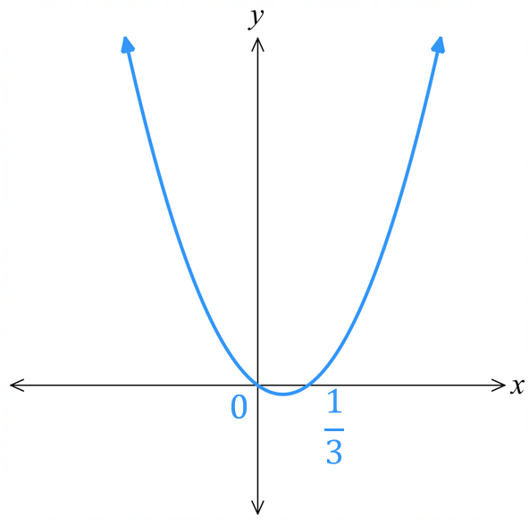  2. $x≠0$,  but this doesn’t change our answer  $$∴x<0, x>\frac{1}{3}$$ | Graphical representation:  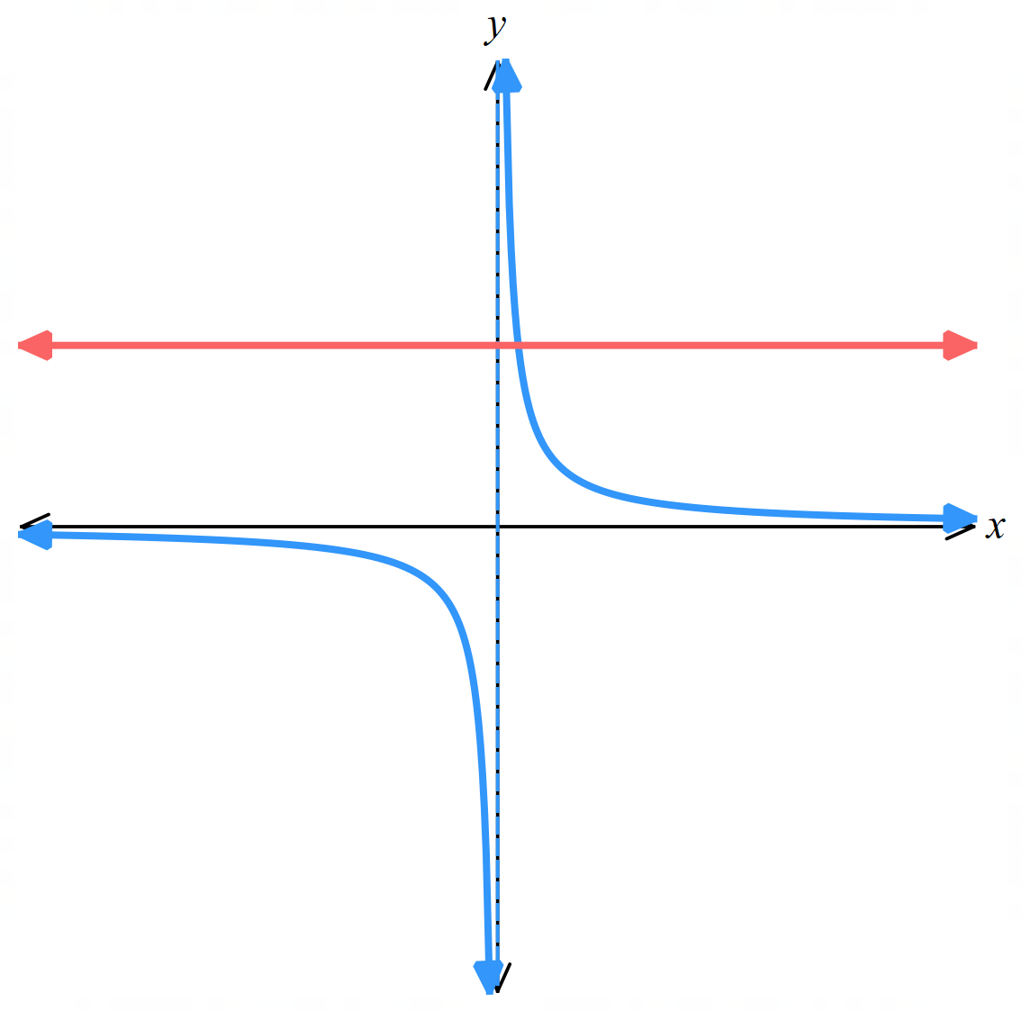

- Guided Practice
Solve:
- $\frac{3}{x}≥8$ | - $\frac{6}{x-2}≥3$
- $\frac{5}{x+3}≥1$ | - $\frac{5}{x+3}≤1$
- $\frac{x^{2}-3x+10}{x+3}≤2$ | - $\frac{x^{2}-9}{x+3}≤1$  Do not cancel factors!

Foundation
- Solve:
$$\frac{1}{x}>1$$  $$0<x<1$$ | $$\frac{3}{x}<1$$  $x<0$, $x>3$ | $$4+\frac{3}{x}≥0$$  $$x≤-\frac{3}{4}, x>0$$

- Consider $\frac{2}{x+1}$ $≤4$
  - Write the restriction on the values of $x$.

$$x≠-1$$
  - Multiply both sides by ${\left(x+1\right)}^{2}$ to show $4{\left(x+1\right)}^{2}-2\left(x+1\right)≥0$

  - Factorise out $\left(x+1\right)$ and show this simplifies to $\left(x+1\right)\left(2x+1\right)≥0$

  - By solving the quadratic inequality, solve $\frac{2}{x+1}$ $≤4$
(remember to check the restrictions)

$$x<-1, x≥-\frac{1}{2}$$

Development
- Solve
$$\frac{2}{x+1}≤1$$  $$x<-1, x≥1$$ | $$\frac{2}{x-3}>1$$  $$3<x<5$$
$$\frac{3}{x+4}≥2$$  $$-4<x≤-\frac{5}{2}$$ | $$\frac{5}{2x-3}<1$$  $$x <\frac{3}{2},x>4$$
$$\frac{2}{3-x}>1$$  $$1<x<3$$ | $$\frac{4}{5-3x}≤-1$$  $$\frac{5}{3}<x≤3$$

Mastery
- Solve
$$\frac{5x}{2x-1}≥3$$  $$\frac{1}{2}<x≤3$$ | $$\frac{2x-3}{x+4}≤1$$  $$-4<x≤7$$
$$\frac{2x+5}{x+3}<1$$  $$-3<x<-2$$ | $$\frac{x(x+3)}{x+1}<2$$  $$x<-2, -1<x<1$$
$$\frac{x^{2}-4}{x-2}>0$$  $$x>-2, x≠2$$ | $$\frac{4}{x-3}≤x$$  $$-1≤x<3, x≥4$$
$$\frac{1}{x}≤\frac{1}{x+2}$$  $$-2<x<0$$ | $$x+\frac{1}{x}≥2$$  $$x>0$$

- Solve this polynomial inequality by sketching the graph.
$$x\left(x+2\right)(x-1)(x+4)≥0$$

$$x≤-4, -2≤x≤0, x≥1$$
- Solve $1+2x-x^{2}≥$ $\frac{2}{x}$

$$x^{2}+2x^{3}-x^{4}≥2x$$
$$-x^{4}+2x^{3}+x^{2}-2x≥0$$
$$x^{4}-2x^{3}-x^{2}+2x≤0$$
$$x^{3}\left(x-2\right)-x\left(x-2\right)≤0$$
$$\left(x-2\right)\left(x^{3}-x\right)≤0$$
$$x\left(x-2\right)\left(x^{2}-1\right)≤0$$
$$x\left(x-2\right)\left(x-1\right)\left(x+1\right)≤0$$
By sketching the polynomial, $-1<x<0, 1<x<2$

Absolute Value Inequalities

- Number Line Representation of Absolute Value Inequalities
$\left|x\right|≤2$ means:  ‘the distance of $x$ from 0 is 2 or less’  Use the number line to answer the question:  $\left|x\right|≤2$,  $2≤x≤2$ | $\left|x\right|>2$ means:  ‘the distance of $x$ from zero is ………’  Use the number line to answer the question:  $\left|x\right|>2,$
$\left|x-1\right|≤2$ means:  ‘the distance of $x$ from 1 is 2 or less’  Use the number line to answer the question:  $\left|x-1\right|≤2$,  …… $≤x≤$ …… | $\left|x-1\right|≥2$ means:  ‘…………………………………………………’;  Use the number line to answer the question:  $\left|x-1\right|≥2$,  ……………………………
$$\left|2x-3\right|≤2$$  This can be rewritten as $|x-$ …… | $≥$ ……  ‘the distance of $x$ from …… is ………...……  Use the number line to answer the question:  $\left|2x-3\right|≤2,$ | $$\left|2x-3\right|≥2$$  This can be rewritten as $|x-$ …… | $≥$ ……  ‘the distance of $x$ from …… is ………...……  Use the number line to answer the question:  $\left|2x-3\right|≥2,$
Complete the sentence:
If the question is $\left|f\left(x\right)\right|<a$, then the answer is …………………………
If the question is $\left|f\left(x\right)\right|>a$, then the answer is …………………………

- Solving Absolute Value Inequalities
When $\left|f\left(x\right)\right|≤a$ (or $≥a$), split into two cases: $f\left(x\right)≤a$ or $-f\left(x\right)≤a$ and solve.

When $\left|f\left(x\right)\right|≤g\left(x\right),$ you can solve it graphically, square both sides, or consider cases.

- Do not do $f\left(x\right)≤±a$ as this means the inequality direction will be incorrect.
- Generally, you are not required to square both sides or consider cases in the HSC course.

- Example Solve absolute value inequalities
Solve  $$\left|2x-4\right|<10$$  $$∴3<x<7$$ | Graphical representation:  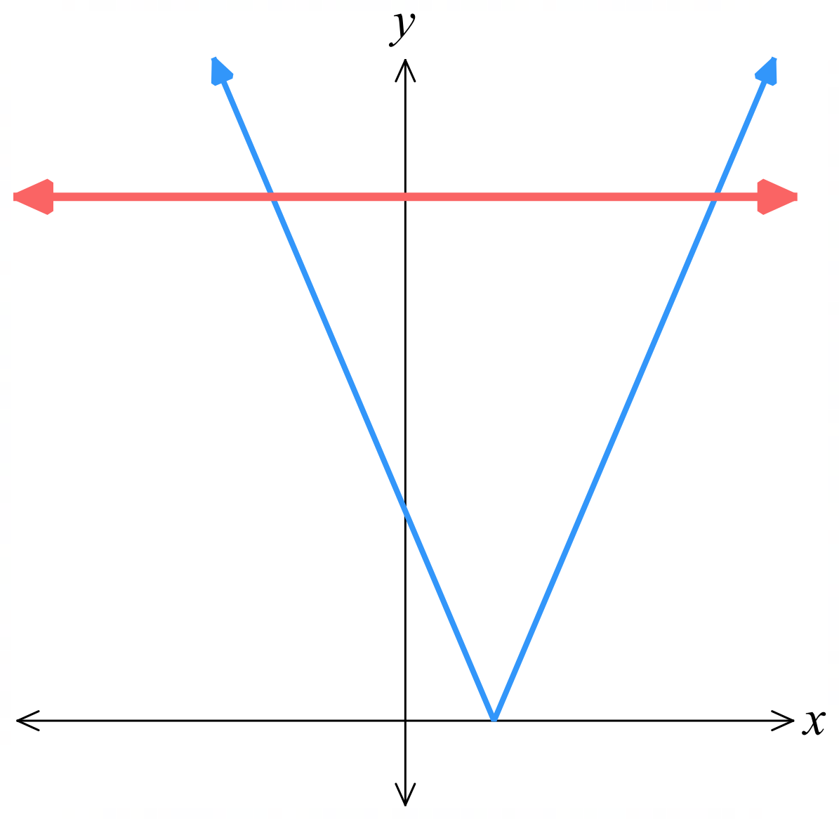
  $$2x-4<10$$  $2x<14$  $$x<7$$ | $$-\left(2x-4\right)<10 \\ -2x+4<10 \\ -2x<6 \\ x>3$$

- Guided Practice
Solve, and sketch the graphical representation.
- $\left|x-5\right|≤1$ | - $\left|5x+7\right|≥3$
- $\left|4x-5\right|>2x+3$ | - $\left|x-1\right|≥$ $\frac{3}{x+1}$  Solve this graphically by considering the points of intersection.  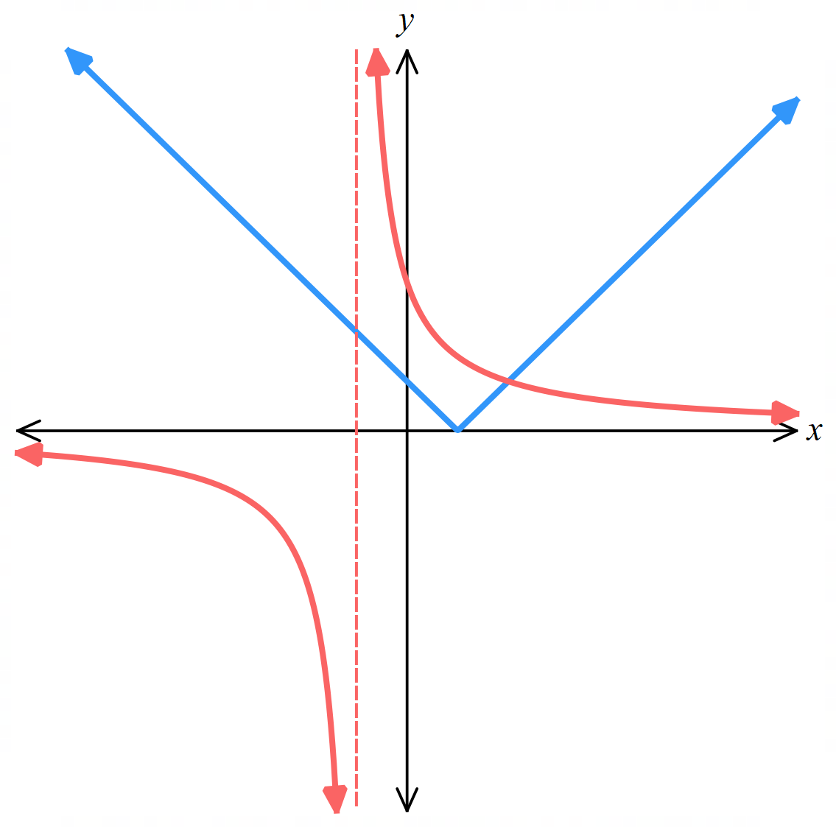

Foundation
- Solve these inequalities. A graphical representation is given.
- $\left|x\right|≤2$  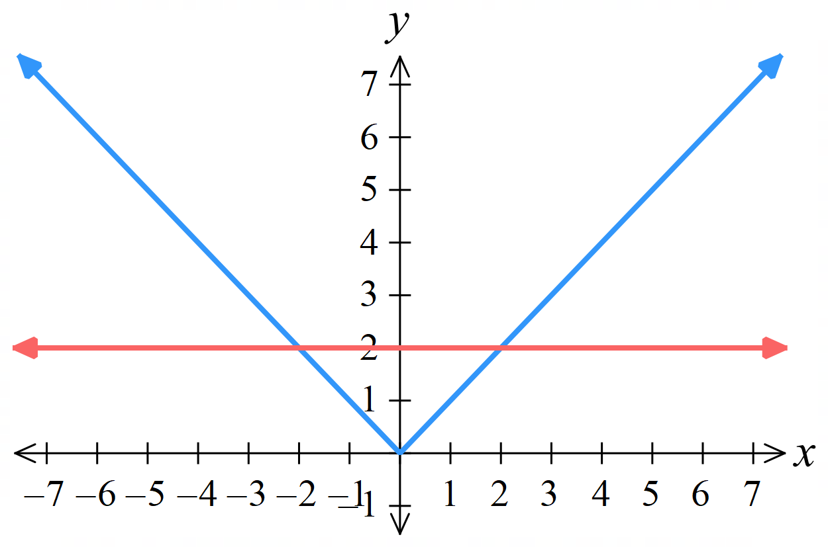  $$-2≤x≤2$$ | - $\left|x\right|>5$  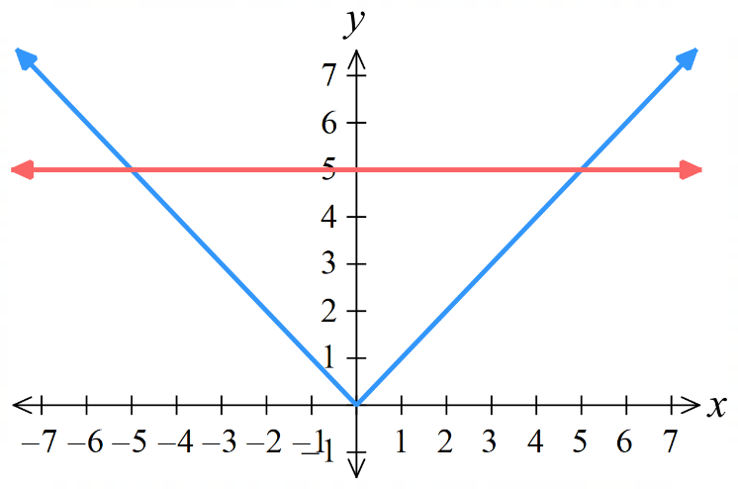  $$x<-5, x>5$$ | - $\left|x\right|<3$  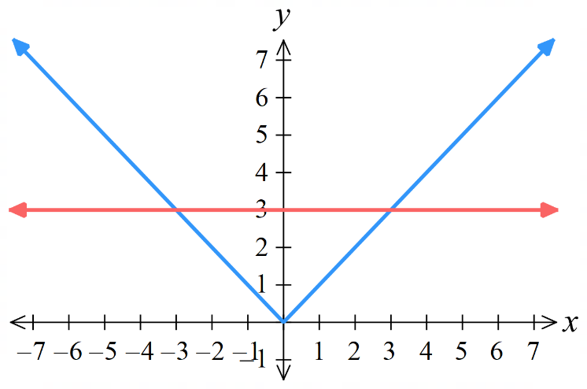  $$-3<x<3$$
- $\left|x-1\right|<2$  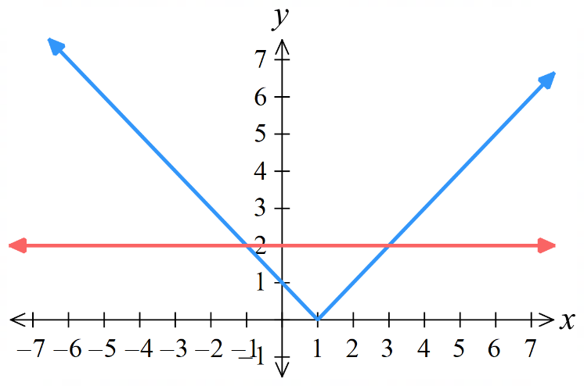  $$-1<x<3$$ | - $\left|x-2\right|≥4$  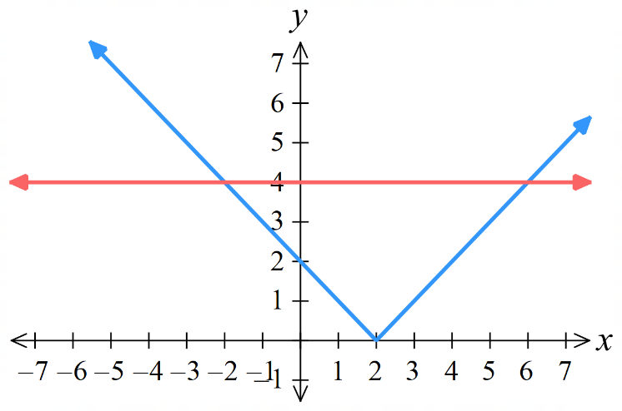  $$x≤-2, x≥6$$ | - $\left|x+1\right|>3$  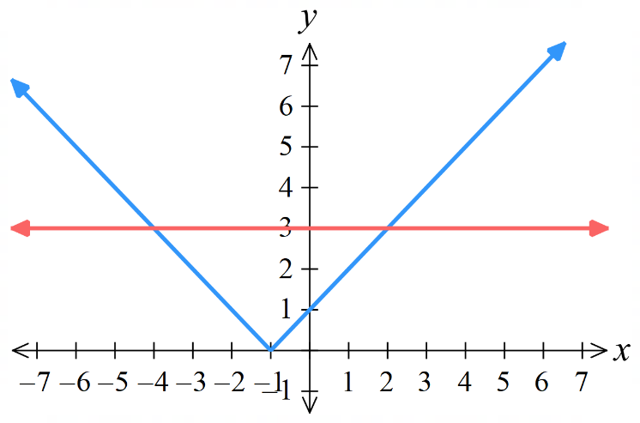  $$x<-4, x>2$$

- Solve these inequalities algebraically.
- $\left|x\right|≥4$  $$x≤-4, x≥4$$ | - $\left|x+1\right|<3$  $$-4<x<2$$ | - $\left|x-3\right|≥2$  $$x≥5, x≤1$$
- $\left|x-2\right|<3$  $$-1<x<5$$ | - $\left|3x-5\right|≤4$  $$\frac{1}{3}≤ x≤3$$ | - $\left|x-7\right|≥2$  $$x≥9, x≤5$$
- $\left|2x+1\right|<3$  $$-2<x<1$$ | - $\left|6x-7\right|>5$  $$x<\frac{1}{3}, x>2$$ | - $\left|5x+4\right|≥6$  $$x≥\frac{2}{5}, x≤-2$$

Development
- Solve:
- $\left|6x-7\right|>5$  $$x>2, x<\frac{1}{3}$$ | - $\left|7-6x\right|>5$  $$x>2, x<\frac{1}{3}$$
Explain why the answers are the same.

Due to the identity $\left|ax-b\right|=\left|b-ax\right|$
- Solve:
- $\left|\frac{a}{2}-3\right|≤2$  $$2≤a≤10$$ | - $14>\left|8-2x\right|$  $$-3<x<11$$ | - $11≤\left|6-5n\right|$  $$n≤-1, n≥\frac{17}{5}$$

- Explain why:
  - $\left|ax+b\right|≥0$ is true for all real values of $x$.

Absolute value cannot be negative,
so this inequality is true for all real $x$
  - $\left|ax+b\right|>0$ is true for all real values of $x$, except $x=-\frac{b}{a}$
$$ax+b≠0$$
$$∴x≠-\frac{b}{a}$$
  - $\left|ax+b\right|<0$ has no solution,

Absolute value cannot be negative,
so this inequality is false for all real $x$
  - $\left|ax+b\right|≤0$ has only one solution.

Absolute value cannot be negative.
so this inequality is only true when $ax+b=0;x=-$ $\frac{b}{a}$

Mastery
- Solve these inequalities.
- $\left|x+5\right|≥0$  All real $x$ | - $\left|4-x\right|≤0$  $$x=4$$ | - $\left|3x-4\right|>0$  All real $x$ except $x≠$ $\frac{4}{3}$
- $\left|4-3x\right|<0$  No solution | - $\left|4-x\right|≤0$  $$x=4$$ | - $\left|3x+2\right|<-7$  No solution
- $\left|3x-4\right|>-1$  All real $x$ | - $\left|2x+5\right|<-2$  No solution | - $\left|3x+5\right|≤0$  $$x=\frac{5}{3}$$

- Solve
$$\frac{1}{\left|2x-1\right|}<2$$

Reciprocate both sides
$$\left|2x-1\right|>\frac{1}{2}$$
$$2x-1>\frac{1}{2}, -2x+1>\frac{1}{2}$$
$$x>\frac{3}{4}, x<\frac{1}{4}$$
The next questions involve solving an absolute value inequality where there is a function on both sides. We must either solve it graphically or consider cases.
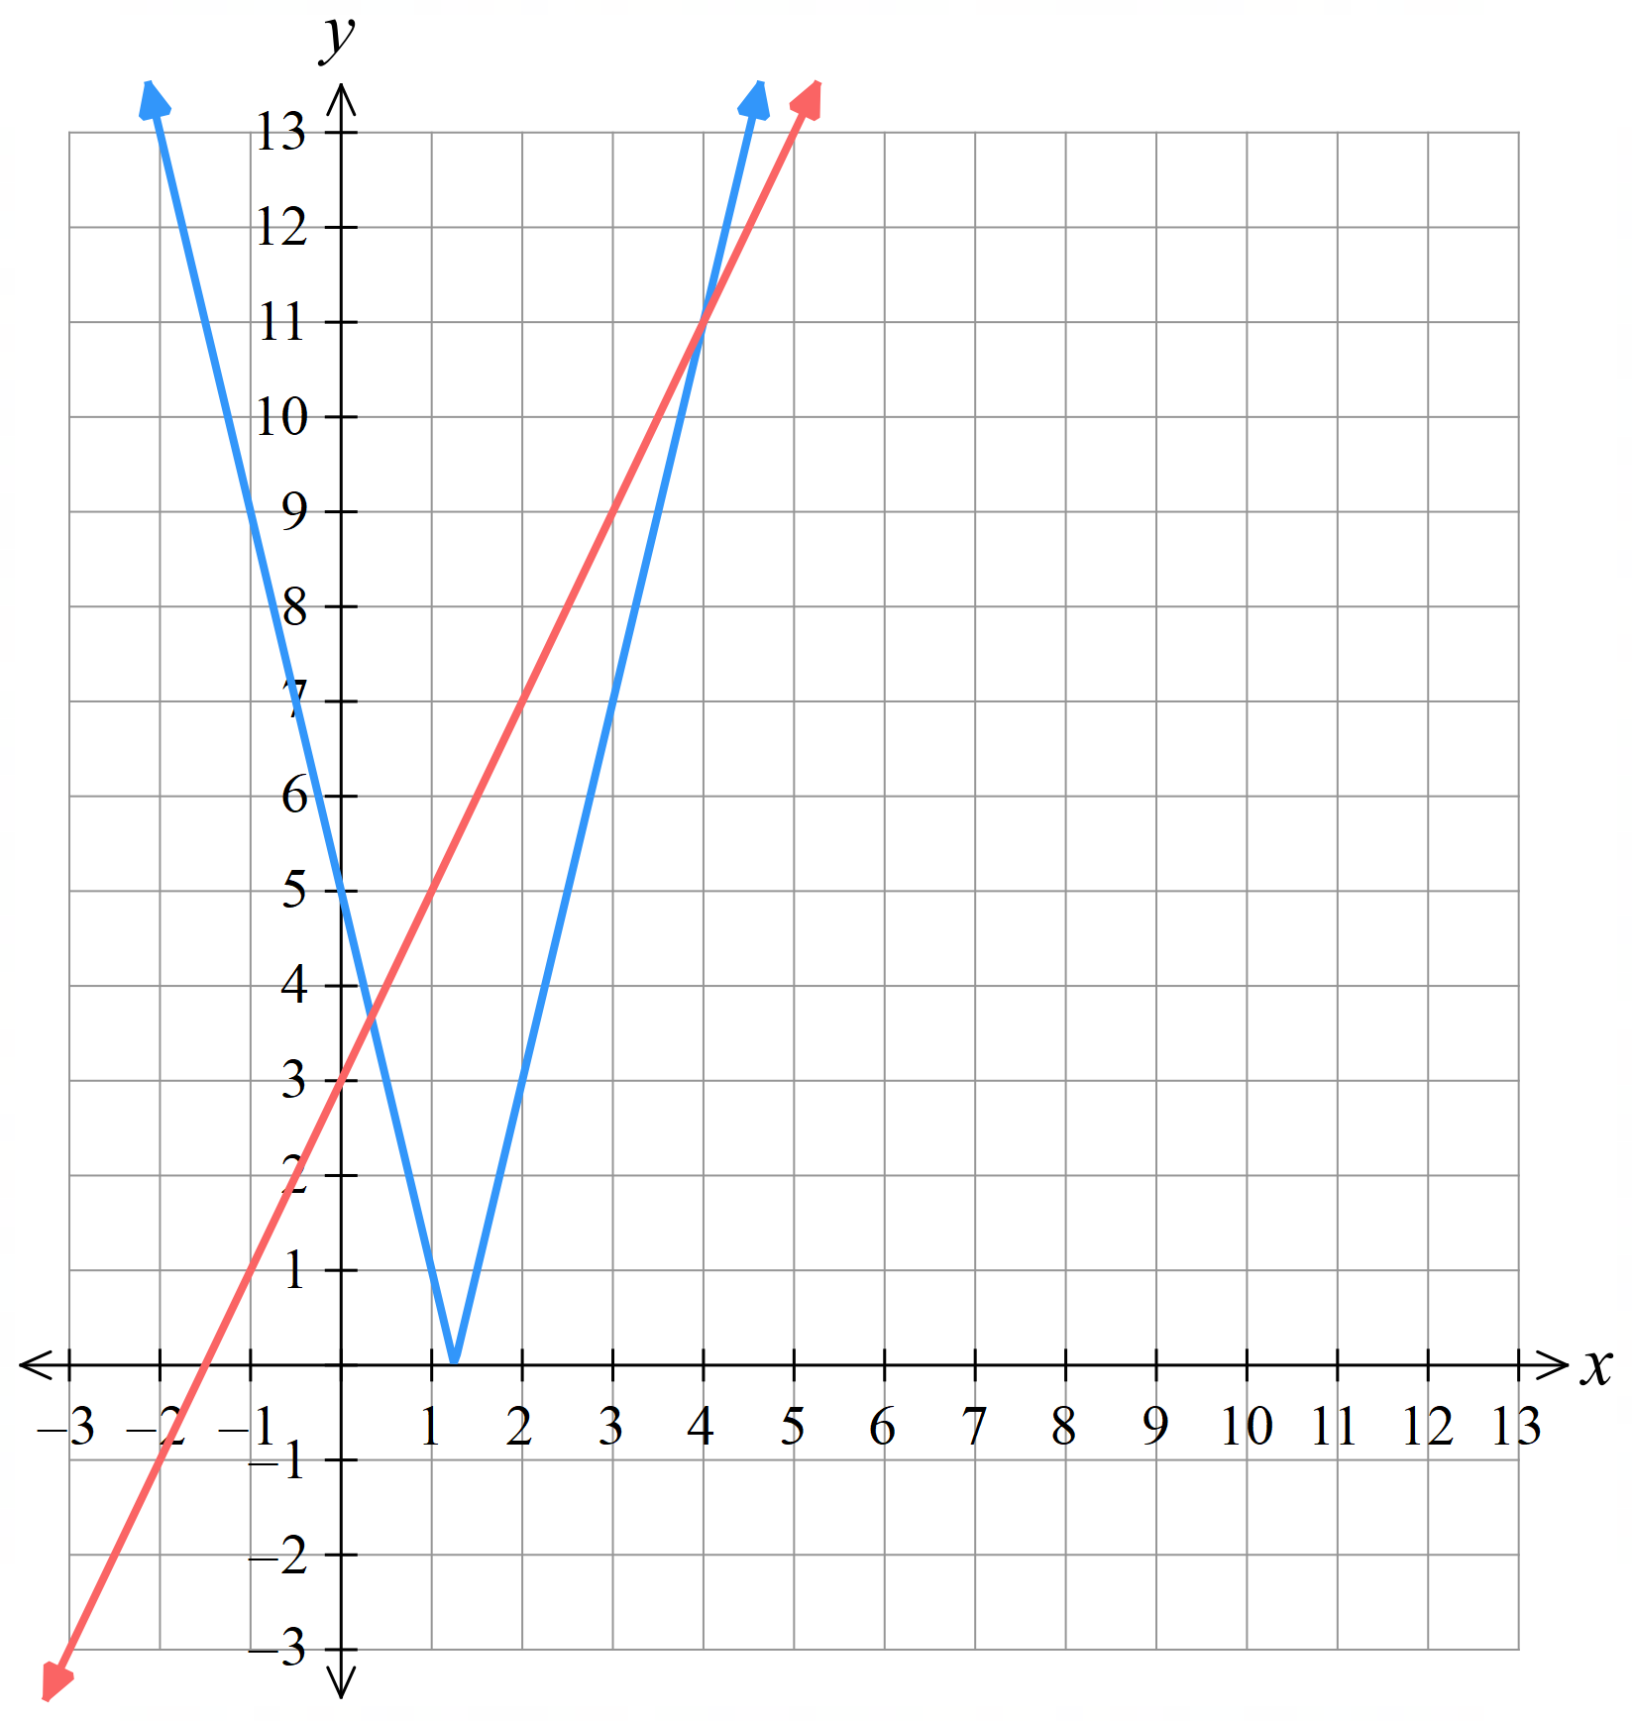
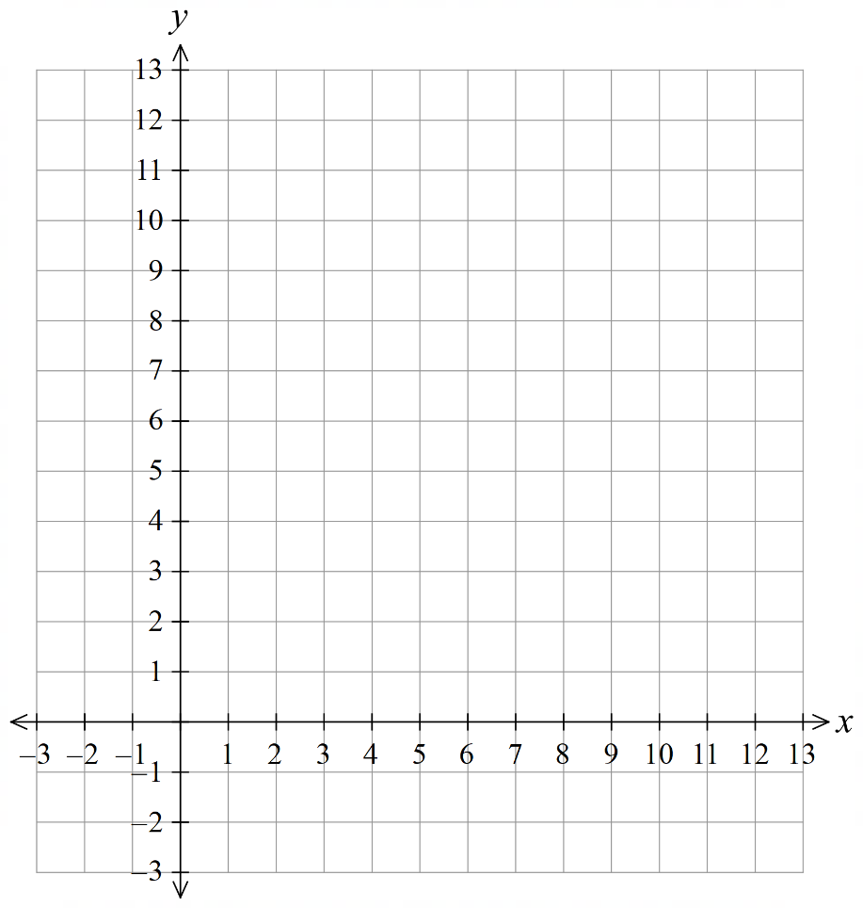
- Sketch $y=\left|4x-5\right|$ and $y=2x+3$ on the same axis, hence solve $\left|4x-5\right|>2x+3$.

By observing when the graph of $|4x-5|$ is above $2x+3$
$$x>4, x<\frac{1}{3}$$

- Solve $\left|2x+1\right|≤\left|x-4\right|$ by following these steps:
  - Sketch both curves, try to be as accurate as possible.

  - Identify which “branches” of the graphs intersect.

$y=2x+1$ intersects with $y=-\left(x-4\right)$
and $y=-\left(2x+1\right)$ intersects with $y=-\left(x-4\right)$
  - Find the points of intersection.

$$2x+1=-\left(x-4\right)$$
$$-\left(2x+1\right)=-\left(x-4\right)$$
The points of intersection are at $x=-5$ and 1
  - Hence solve the inequality.

By examining the graph:
$$-5≤x≤1$$
- 2008 VCE Band 4
Solve $\left|2x-1\right|≤\left|x-3\right|$.
(hint: sketch the curves)

$$-2≤x≤\frac{4}{3}$$

- 2024 HSC Extension 1 Band 4
The diagram shows the graph of $y=$ $\frac{1}{\left|x-5\right|}$
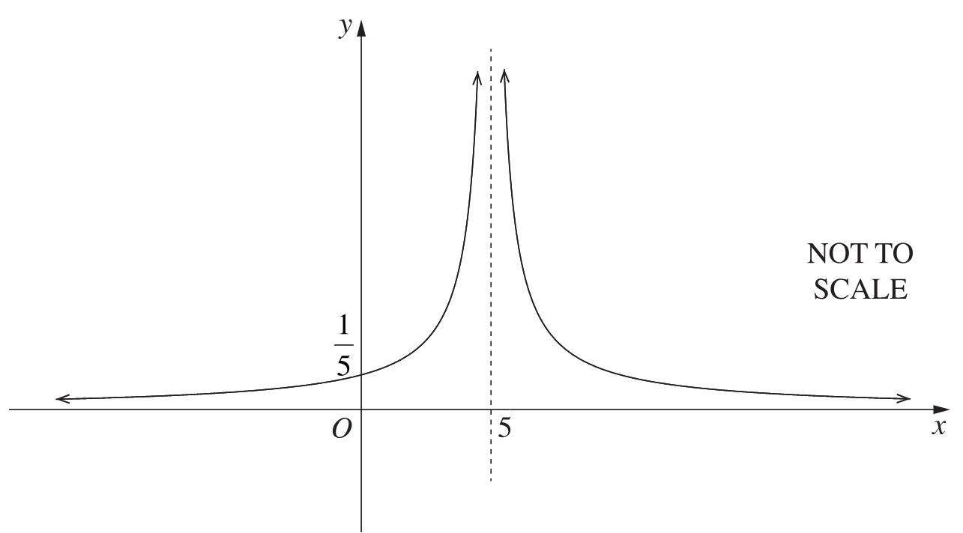

Solve $\frac{x}{6}$ $≥$ $\frac{1}{\left|x-5\right|}$ by following these steps:
  - Show that $x\left|x-5\right|≥6$. Explain why we do not need to multiply by the square of $\left|x-5\right|$.

Cross multiply: $x\left|x-5\right|≥6$
we do not need to multiply by the square as $\left|x-5\right|$ must be positive
  - Find the points of intersection by solving $x\left|x-5\right|=6$

$x\left(x-5\right)=6$
$$x^{2}-5x-6=0$$
$$\left(x-6\right)\left(x+1\right)=0$$
$$x=6, -1$$

$$-x\left(x-5\right)=6$$
$-x^{2}+5x-6=0$
$$x^{2}-5x+6=0$$
$$\left(x-2\right)\left(x-3\right)=0$$
$$x=2, 3$$
  - Therefore, sketch $y=$ $\frac{x}{6}$ and state the solutions to $\frac{x}{6}$ $≥$ $\frac{1}{\left|x-5\right|}$

if you sketch $y=$ $\frac{x}{6}$, there won’t be an intersection point at $x=-1$
by inspecting the graph, $2≤x≤3, x≥6$

- We will solve $\frac{x}{6}$ $≥$ $\frac{1}{\left|x-5\right|}$ without a graph by considering cases.
  - Show that $x\left|x-5\right|≥6$

Cross multiply: $x\left|x-5\right|≥6$
(we do not switch the inequality sign as $\left|x-5\right|$ is positive)
  - Consider $\left|x-5\right|$ as the piecewise function:
$$\left|x-5\right|=\left\{\begin{matrix}x-5, \text{for} x≥5, \\ -\left(x-5\right), \text{for} x<5\end{matrix}\right.$$

Therefore, remove the absolute value signs and solve $x\left|x-5\right|≥6$:
(you will need to use quadratic inequalities)
$$x≥5$$  For $x≥5$: $x\left(x-5\right)≥6$  $$x^{2}-5x-6≥0$$  $$\left(x-6\right)\left(x+1\right)≥0$$  $$x≥6, x≤-1$$  But $x≤-1$ is not a solution as $x≥5$ | $x<5:$  For $x<5$: $-x\left(x-5\right)≥6$  $-x^{2}+5x-6≥0$  $$x^{2}-5x+6≤0$$  $$\left(x-2\right)\left(x-3\right)≤0$$  $$2≤x≤3$$

  - Explain why $x≤-1$ is not a solution to the inequality.

We found $x≤-1$ when we considered the case $x≥5$, which is a contradiction.
  - Therefore, state the solution to the inequality $\frac{x}{6}$ $≥$ $\frac{1}{\left|x-5\right|}$
$$∴2≤x≤3, x≥6$$

- 2020 VCE Band 4
Solve $3-x>$ $\frac{1}{|x-4|}$

$$\left(3-x\right)\left|x-4\right|>1$$
For $x>4$, $\left(3-x\right)\left(x-4\right)>1$
$$-x^{2}+7x-12>1$$
$$-x^{2}+7x-13>0$$
No solution as $Δ<0$

For $x<4$, $-\left(3-x\right)\left(x-4\right)>1$
$$x^{2}-7x+11>0$$
$$x<\frac{7-\sqrt{5}}{2}, x>\frac{7+\sqrt{5}}{2}$$
But since this is for the case $x<4$,
$x<$ $\frac{7-\sqrt{5}}{2}$ is the only solution.
- Consider the inequality
$$\left|x+\frac{1}{x}\right|<2x$$
  - Explain why $x$ must be positive.

Since $\left|x+\frac{1}{x}\right|$ $>0$, $2x>0,$ so $x>0$
  - Hence explain why $x+$ $\frac{1}{x}$ must be positive.

A positive number plus its reciprocal must also be positive.
  - Solve the inequality.

$$x+\frac{1}{x}<2x$$
$$x^{3}+x<2x^{3}$$
$$-x^{3}+x<0$$
$$x^{3}-x>0$$
$$x\left(x^{2}-1\right)>0$$
$$x\left(x-1\right)\left(x+1\right)>0$$
$-1<x<0$, $x>1$
But since $x>0, x>1$ is the only correct solution.
since $x+$ $\frac{1}{x}$ $>0$, we do not need to consider the case where $x+$ $\frac{1}{x}$ $<0$
$∴x>1$ is the only solution.

- Solve $\left|x\right|-2<4-x^{2}$
$$\left|x\right|<6-x^{2}$$

$$x>0:x<6-x^{2}$$
$$x^{2}+x-6<0$$
$$\left(x+3\right)\left(x-2\right)<0$$
$$-3<x<2$$

$$x<0:-x<6-x^{2}$$
$$x^{2}-x+6<0$$
$$\left(x-3\right)\left(x+2\right)<0$$
$$-2<x<3$$

The inequality that satisfies both $-3<x<2$ and $-2<x<3$is
$$-2<x<2$$

